Executable Cinema: The Bell Labs Computer Movie Lineage and the Genesis of Computational Image Media (1963–1968)

Introduction: The Epistemic Shift Toward Operative Ekphrasis
Between the pivotal years of 1963 and 1968, the unique research environment at Bell Telephone Laboratories fundamentally altered the ontological status of the motion picture. The institutional substrate of Bell Labs did not merely apply computers to the pre-existing medium of film; rather, it transformed film into an executable technical object.¹ This period marks a profound media-archaeological rupture. The motion picture evolved from a photographically captured record of physical reality—reliant on the physics of optics and photochemistry—into an algorithmic manifestation of programmed logic. During this narrow but explosive window of innovation, calculation became image, image became motion, and motion became what can be termed a "worldtext"—a visual space governed entirely by operative linguistic commands.
The locus of this transformation resides in a specific cluster of technological innovations, programmatic paradigms, and cross-disciplinary collaborations that emerged within the confines of Bell Labs in Murray Hill, New Jersey.¹ The lineage connecting these innovations traces a trajectory from pure mathematics to avant-garde poetry. It binds Edward E. Zajac’s pioneering scientific simulation animations to Kenneth C. Knowlton’s invention of BEFLIX, the world's first dedicated computer animation programming language.¹ It extends into Knowlton and Leon Harmon’s groundbreaking explorations into gray-scale image synthesis, which redefined the limits of human visual perception.⁴ Finally, it tracks the subsequent migration of these computational tools into experimental cinema through the collaborative Poemfield series produced by Stan VanDerBeek and Knowlton.⁶
To rigorously trace this lineage is to observe how computer programs became instruments not just for calculation, but for producing motion, perception, image, simulation, and poetic cinema. In Zajac’s work, the movie serves as a scientific simulation made visible. It functioned as an elegant solution to the epistemic bottleneck of interpreting vast matrices of numerical data regarding satellite orbital dynamics.⁹ In Knowlton’s software engineering, the movie becomes a programmable sequence of bitmap operations, fundamentally redefining animation as the manipulation of a discrete Cartesian grid through algorithmic subroutines.¹
In the perceptual collaborations between Harmon and Knowlton, the discrete, binary logic of the computer is mapped directly onto the psychophysics of human vision, turning gray-scale synthesis into a cognitive experiment that inadvertently birthed one of the most famous pieces of early digital art.⁴ Finally, in VanDerBeek and Knowlton’s cinematic collaborations, executable cinema achieves an avant-garde synthesis, turning the output of an IBM 7094 mainframe and a Stromberg-Carlson 4020 microfilm recorder into an algorithmic, typographic dreamscape.⁶
This exhaustive research report reconstructs the verified, annotated research map of Bell Labs computer movie sources, detailing the precise technical, mathematical, and aesthetic mechanisms that drove this media evolution. It establishes that early computer animation was not solely a novel visual technique mimicking traditional drawing, but rather an entirely new operational language for producing spatial and temporal meaning—an architecture of operative ekphrasis where the descriptive text (the code) literally does what it describes.

Part I — Annotated Source Table and Categorical Taxonomy
The historiography of early computer graphics frequently flattens distinct innovations into a monolith. To avoid collapsing all Bell Labs outputs into a generic "computer art" category, the following verified primary and secondary sources have been extracted, annotated, and classified. This table serves as the foundational architecture to trace the technical, aesthetic, and institutional ecology of early computer movie production.

Annotated Source Table: The Bell Labs Computer Movie Cluster

Year | Source Title / Artifact | Creator(s) | Type | Contribution | Link / Archive | Confidence
1963 | Simulation of a Two-Gyro Gravity-Gradient Attitude Control System | Edward E. Zajac | Film | Recognized as the first computer-animated scientific simulation film. Generated motion from FORTRAN calculations printed to microfilm. | AT&T Archives / History of Information ³ | High
1964 | "A Computer Technique for Producing Animated Movies" | Kenneth C. Knowlton | Paper | Introduces BEFLIX, the first bitmap movie language, establishing programming as cinematic instruction operating on a 252x184 grid. | AFIPS Spring Joint Computer Conference ¹ | High
1964 | "Computer-Made Perspective Movies as a Scientific and Communication Tool" | Edward E. Zajac | Paper | Details the generation of perspective graphics for complex simulation, optimizing computer I/O by plotting directly to microfilm. | Commun. ACM ¹⁷ | High
1964 | "A Two-Gyro, Gravity-Gradient Satellite Attitude Control System" | J.A. Lewis, E.E. Zajac | Paper | Provides the rigorous technical and mathematical foundation (transient response, multi-body physical phenomena) visualized in the 1963 simulation film. | Bell System Technical Journal ¹¹ | High
1965 | "Computer Animation: A New Scientific and Educational Tool" | Edward E. Zajac | Article | Frames computer animation as an educational and scientific necessity for absorbing high-speed numerical data outputs. | SMPTE Journal ⁹ | High
1965 | "Computer-Produced Movies" | Kenneth C. Knowlton | Article | Frames the economic and technical viability of computer-controlled display tubes and cameras producing animated films quickly and economically. | Science ¹ | High
1966 | "Film Animation by Computer" | Edward E. Zajac | Article | Explains computer animation to a broader scientific audience, explicitly incorporating Knowlton's BEFLIX methods alongside geometric simulation. | New Scientist ³ | High
1966-71 | Poemfield series (Nos. 1-10) | Stan VanDerBeek, K. Knowlton | Film | Transforms BEFLIX and TARPS into experimental typographic poetry, adding optical color post-computation to algorithmic outputs. | Various Archives / DOCUMENT Gallery / Tate ⁶ | High
1967 | Computer Nude (Studies in Perception I) | Leon Harmon, K. Knowlton | Artifact | Pioneers digital image processing and computer art by synthesizing gray scales using typographic symbols to represent analog voltage data. | E.A.T. / MoMA / Henry Ford / Buffalo AKG ⁵ | High
1968 | An Evening of Computer-Produced Films | Museum of Modern Art | Event | Institutionalizes Bell Labs computer films within the art-historical canon during The Machine as Seen at the End of the Mechanical Age exhibition. | MoMA Archives ²⁶ | High
1972 | "Computer-Produced Grey Scales" | K. Knowlton, L. Harmon | Paper | Outlines the technical algorithms for quantizing space into cells filled with specific patterns to derive subjective perceptual gray values. | Visible Language ⁴ | High
2016 | "Early Digital Art at Bell Labs" | A. Michael Noll | Article | Provides primary historical framing on the institutional ecosystem of the 1960s, documenting the hardware paradigms and the origins of algorithmic art. | Leonardo / JSTOR / USC Annenberg ⁸ | High

Analytic Classification and the Identification of Bridges
The diverse outputs of the Bell Labs media ecology cannot be uniformly collapsed under a single aesthetic or technical umbrella. A rigorous media-archaeological approach requires assigning each source to specific analytic categories that illuminate their distinct operational functions, followed by identifying the specific technological or institutional bridges that connect them.¹
Categorical Taxonomy:
- <programming-language-for-animation>: Knowlton's 1964 paper on BEFLIX directly inhabits this space. It represents the foundational architectural logic of pixel manipulation and algorithmic subroutine formulation for the explicit purpose of moving image creation.¹
- <simulation-film> & <scientific-visualization>: Zajac's 1963 film and subsequent 1964/1965 papers inhabit this space. Crucially, his animations do not simulate reality for aesthetic purposes; they operate as mathematical plotting in temporal space to solve engineering problems regarding satellite orientation.⁹
- <gray-scale-image-synthesis> & <visual-perception-experiment>: The Harmon and Knowlton outputs (Studies in Perception I, 1972 Visible Language paper) belong to this domain. Their primary objective was investigating the cognitive processing of binary output devices and the neurophysiology of pattern recognition.⁴
- <experimental-film> & <typographic-animation>: VanDerBeek and Knowlton’s Poemfield series utilizes computational logic as an avant-garde poetic medium, manipulating language and geometric forms in temporal cinematic space.⁶
- <institutional-history> & <museum-contextualization>: The historical documentation provided by A. Michael Noll and the MoMA archival records of the 1968 The Machine exhibition fall under this category, explaining how corporate laboratories became accidental incubators for digital avant-gardism.⁸
Identifying the Bridges:
The institutional substrate of Bell Labs forced these distinct technical vectors to intersect in profound ways.
- <BEFLIX> functions as the definitive bridge between <programming-language-for-animation> and <experimental-film>. Knowlton designed it for engineering visualization, but its underlying linguistic structure made it highly adaptable for VanDerBeek’s poetic world-building.²
- <Zajac's 1963 satellite film> acts as the primary bridge between pure mathematics <perspective-graphics> and accessible <scientific-visualization>, proving that film could act as a translational layer between mainframe calculations and human comprehension.³
- <Harmon-Knowlton gray-scale work> bridges the stringent parameters of a <visual-perception-experiment> with the cultural impact of <computer-art>. What began as an inquiry into human optical resolution became a defining aesthetic artifact of the late 1960s, culminating in its exhibition at MoMA and broad cultural circulation.⁵

Part II — The Lineage Map of Computational Motion
The passage from raw electrical calculation to poetic computer cinema was neither instantaneous nor accidental. It required a highly sequential development of hardware interfaces, coding architectures, perceptual theories, and cross-disciplinary interventions. The lineage of executable cinema at Bell Labs can be explicitly mapped through the following nodes of transition:
- <Bell Labs computation>: The baseline institutional substrate of the early 1960s, characterized by the use of IBM 7090 and 7094 mainframe computers, massive punch-card data entry, and the need to process overwhelmingly complex mathematical models.²
- <programmed image>: The initial visualization phase. This includes Frank Sinden's ORBIT logic and A. Michael Noll's 1962/1963 Gaussian-Quadratic experiments, where algorithms calculated Gaussian random numbers combined with quadratic equations to plot static vectors on microfilm.³
- <animated frame sequence>: The critical leap introduced by Knowlton's BEFLIX (1963/1964). Here, the computer transitions from plotting random static lines to mapping deliberate, sequential pixel operations across a defined 252x184 grid, automating the repetitive labor of animation.¹
- <scientific simulation>: Concurrently in 1963, Zajac utilizes FORTRAN to calculate the dynamic physics of satellite gyroscopes, writing the sequential orientation data to a device that renders it as a continuous temporal simulation.³
- <computer-produced movie>: The crystallization of the medium. Knowlton defines the economic and technical viability of utilizing microfilm plotting (the SC-4020) and cathode-ray tubes to generate films without physical ink or paper, as outlined in his 1965 Science article.¹
- <gray-scale perception image>: Harmon and Knowlton (1966/1967) push the hardware beyond high-contrast vectors. They convert analog voltages of photographs into discrete binary numbers, using typographic characters to simulate tonal depth and test human perceptual limits.⁴
- <experimental computer film>: The aesthetic culmination (1966–1971). VanDerBeek and Knowlton compile "worldtext" and optical color into the Poemfields, utilizing the machine's intrinsic capabilities for text and logic to create psychedelic, kinetic poetry.⁶
- <museum / art-historical canonization>: The institutional validation. MoMA's 1968 exhibition The Machine as Seen at the End of the Mechanical Age, paired with E.A.T. collaborations, permanently positions Bell Labs' executable code within the narrative of art history.⁵

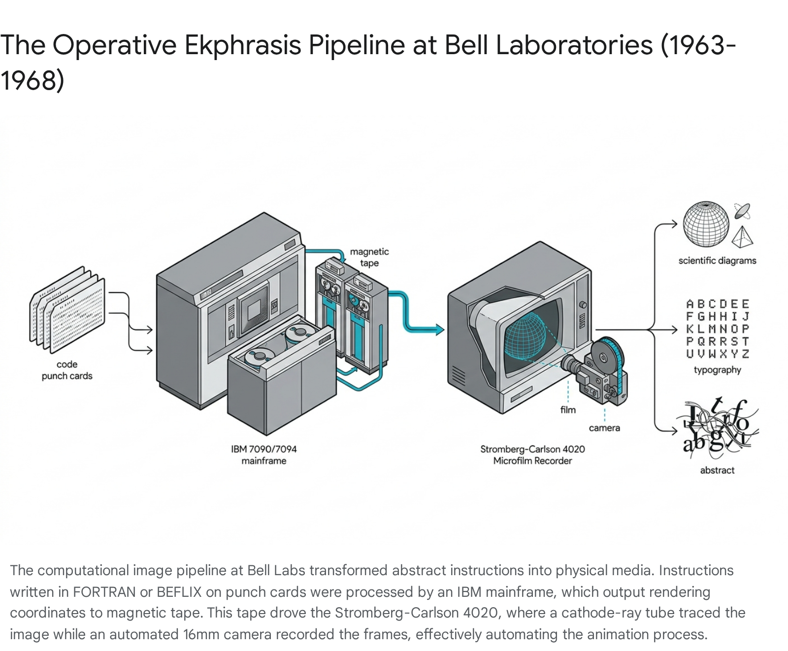

The progression outlined above underscores the central operational philosophy at Bell Labs during this era: the computer was not recognized merely as a high-tech drawing tool. It was understood fundamentally as a logic engine that required complex ekphrastic translation—writing code to describe visual space—to output visual phenomena.²

Part III — Research Brief: Synthesizing the Media-Archaeological Lineage
The transformation of mainframe computer technology into an engine for moving-image production represents one of the most critical thresholds in modern media archaeology. The primary and secondary sources gathered from the 1963–1968 Bell Labs era reveal a highly coherent, interconnected lineage. This history demonstrates how early computer animation transcended simple visual novelty to establish an entirely new operational language that would dictate the future of digital simulation, data visualization, and computational art.

Computation as Image-Making and Programming as Cinematic Instruction
The genesis of this lineage is inherently tied to the rigid hardware constraints and limited graphical capabilities of the early 1960s. Prior to the targeted interventions of Kenneth Knowlton, computer graphics were largely restricted to vector-based line plotting—the calculation of starting and ending points for an electron beam to trace simple geometric forms on an oscilloscope or plotting device, as seen in A. Michael Noll's 1962 Gaussian-Quadratic work.⁸
In 1963, Kenneth Knowlton introduced a paradigm shift by developing BEFLIX (Bell Flicks). Recognized today as the first embedded domain-specific language explicitly developed for computer animation, BEFLIX fundamentally altered the relationship between the machine and the image.¹ Knowlton shifted the paradigm from continuous vector lines to a discrete bitmap logic. With BEFLIX, programming was transformed into cinematic instruction. The animator or engineer did not manually draw frames; rather, they wrote a sequential series of subroutines using FORTRAN and FORTRAN Assembly Program (FAP) macros that dictated the specific behavior of pixels.²
As rigorously detailed in his 1964 paper, "A Computer Technique for Producing Animated Movies" (presented at the AFIPS Spring Joint Computer Conference), BEFLIX allowed programmers to manipulate an array of microscopic cells within a fixed resolution matrix of 252 by 184.¹ Each of these localized cells could display one of eight distinct shades of gray.¹ This operational shift from analog drawing to digital coding meant that the movie became, for the first time, an executable file. The IBM 7090 or 7094 mainframe computer interpreted the alphanumeric script, constructed the pictures mathematically within its memory, and wrote the rendering coordinates onto a magnetic tape.²
This magnetic tape was then fed into the Stromberg-Carlson (SC) 4020 microfilm recorder.² Inside the SC-4020, a cathode-ray tube read the tape, tracing the image with an electron beam. An automated, shutterless 16mm camera mounted inside a darkroom enclosure then captured the sequence frame-by-frame as it flashed on the CRT face.⁹ BEFLIX treated the cinematic frame not as a photographic exposure capturing the physical bounce of light off the material world, but as a manipulable data structure—a grid awaiting algorithmic population.² Knowlton would continue to refine this operational ekphrasis by developing subsequent graphics programming languages throughout his career at Bell Labs, including EXPLOR, SPHERES, and ATOMS, further proving the viability of language as an image generator.¹²

Simulation as Visual Explanation: Zajac and the Architecture of the Cosmos
While Knowlton was architecting the programming language necessary for bitmap motion, his colleague Edward E. Zajac was pioneering the use of computer graphics to solve critical aerospace engineering problems. In 1963, Zajac produced what is universally recognized as the first computer-animated scientific film: Simulation of a Two-Gyro Gravity-Gradient Attitude Control System.³ To fully grasp the historical and epistemological impact of Zajac's work, it is imperative not to confuse it with mere artistic expression or aesthetic curiosity; it was a highly pragmatic solution to a complex mathematical bottleneck.
During this period, Zajac and his colleague J.A. Lewis were deep into an analytical and numerical study of passive gravity-gradient attitude control systems for communications satellites.¹¹ The goal was to determine how a satellite—specifically a 300-lb satellite in a 6000-nautical-mile orbit with a 60-foot extensible rod and a 20-lb tip mass—could maintain an Earth-pointing orientation using only the physical forces of gravity and gyroscopic energy dissipation.¹¹ Gravity-gradient systems are inherently "bistable," meaning they can easily settle into an inverted, upside-down equilibrium if disturbed by orbital eccentricity, thermal rod bending, solar torques, magnetic torques, or micrometeorite impact.¹¹
The differential equations governing this multidimensional, non-linear dynamic system were processed by the IBM mainframes, but the output was an overwhelming, unreadable flood of thousands of pages of numerical data representing the transient response and yaw, pitch, and roll axes.⁹ Engineers could not intuitively "see" if the satellite was tumbling or stabilizing by reading printouts.⁹
By programming the orientation calculations in FORTRAN and utilizing a geometric plotting sub-routine called ORBIT—written by his colleague Frank Sinden—Zajac mathematically calculated a perspective view of the satellite.³ He plotted the satellite's orientation as a series of bounding boxes directly onto the SC-4020 microfilm recorder.³ In his influential 1964 paper, "Computer-Made Perspective Movies as a Scientific and Communication Tool," and his subsequent 1965 article in the SMPTE Journal, Zajac explicitly framed the resulting movie as an essential scientific tool.⁹ Zajac’s profound innovation was recognizing that the motion picture medium could serve as a time-based visual explanation for transient, multi-body physical phenomena. The film was the only way to quickly prove that their two-gyro damper system would settle small disturbances within a single orbit.¹¹ Zajac demonstrated that simulation film was an epistemological necessity, turning pure mathematics into a visible physical reality.⁹

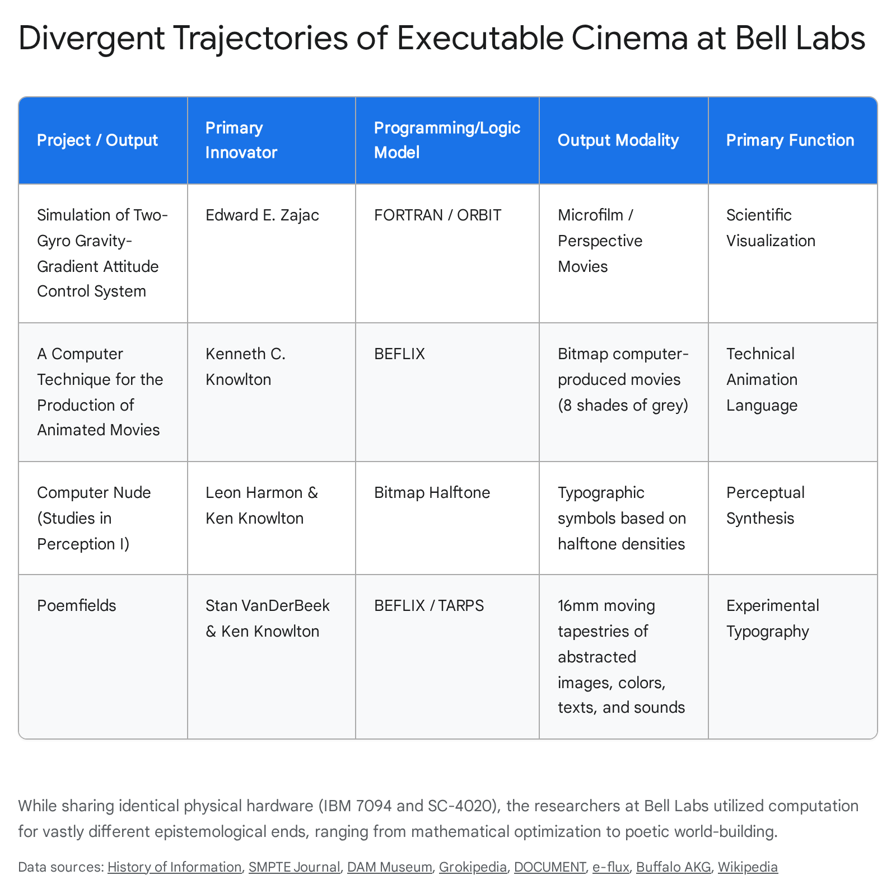

Perceptual Synthesis and Gray Scales: The Computer as Cognitive Mirror
While Zajac visualized macro-physical space and celestial mechanics, Leon Harmon and Kenneth Knowlton turned the computational lens inward, focusing on the psychophysics of human vision. Their 1966/1967 artifact, Computer Nude (Studies in Perception I), represents a profound bridge between visual perception experiments and the nascent field of digital art.⁵
To produce this iconic image, Harmon (a cognitive neuroscience researcher) and Knowlton scanned a photograph of the avant-garde choreographer Deborah Hay. They utilized a special camera setup that converted the continuous analog voltages of the photograph into discrete binary numbers.⁵ These binary numbers were then algorithmically assigned to standard typographic symbols—such as letters, numbers, and mathematical marks—based on their specific, calculated halftone densities.¹³ By quantizing the spatial layout into discrete microscopic cells and applying rules to mimic subjective gray values, Harmon and Knowlton engineered a massive mosaic (the physical photoprint measured 150 by 370 cm).¹²
As extensively detailed in their 1972 paper in Visible Language, "Computer-Produced Grey Scales," this process was initially conceived as an extension of cognitive neuroscience research. They sought to understand how pictorial output from computers, which is "microscopically black or white at a point owing to the physical processes involved," could be perceived by the human brain as having depth, curve, and continuous tone.⁴ It raised critical "intriguing questions about the physiology and psychology of vision".⁴
However, the artifact rapidly transcended the confines of the laboratory. Through the advocacy of the non-profit group Experiments in Art and Technology (E.A.T.)—founded by engineers Billy Klüver and Fred Waldhauer alongside artists Robert Rauschenberg and Robert Whitman—the image was brought into the public sphere. Rauschenberg famously hung a copy of the 12-foot print in his studio during an E.A.T. press conference.⁵ Consequently, on October 11, 1967, the image was reproduced in The New York Times, inadvertently becoming the publication's first full-frontal nude.⁵ While Bell Labs management initially demanded that the researchers dissociate the laboratory's name from the controversial work, the overwhelmingly positive public reception caused the corporation to reverse its directive, proudly claiming the innovation.³³ The gray-scale project demonstrated that the computer image is fundamentally an illusion of spatial quantization—a mosaic that relies heavily on the neurobiology of human perception to resolve rigid algorithmic symbols into soft, organic flesh.⁵

BEFLIX as Worldtext and the Move to Experimental Film
The functional capabilities established by Knowlton's BEFLIX and the aesthetic breakthroughs of perceptual gray-scale manipulation culminated in a radical synthesis when Knowlton began collaborating with the avant-garde filmmaker Stan VanDerBeek. From 1966 to 1971, the duo produced the highly influential Poemfield series (comprising films numbered 1 through 10).⁶
In these collaborative films, the computer screen became what can be termed a "worldtext." Using BEFLIX alongside a specialized macro system created by Knowlton specifically for this collaboration, known as TARPS, VanDerBeek wrote programmatic instructions that produced complex, multilayered moving tapestries of geometric graphics intertwined with cascading typography.⁶ Rather than using the computer to simulate physical reality (as Zajac did with satellites) or to reproduce a photographic representation (as Harmon did with the human form), the Poemfield films utilized the intrinsic, native nature of the computer's memory banks: alphanumeric text and pure logic.⁶
Words and letters dissolve, reform, twinkle, and mutate across the frame. Because the SC-4020 microfilm recorder could only output imagery in stark black and white or varying shades of microfilm gray-scale, the psychedelic, vibrant color palettes associated with the final Poemfields were not generated natively by the IBM 7094.⁸ Instead, VanDerBeek employed complex optical printing techniques, collaborating heavily with experimental filmmakers Bob Brown and Frank Olvey, to colorize the raw algorithmic output in post-production.⁷
The poetry within the films was equally significant. In Poemfield No. 7 (1967-68), for example, VanDerBeek programmed a poem by the nonviolent social activist A.J. Muste, which declared: "THERE IS NO WAY TO PEACE; PEACE IS THE WAY; NO MORE WAR".⁶ This text was combined with a soundtrack featuring movements from John Cage's composition Amores.⁶ Here, the motion picture is fully realized as operative ekphrasis—a linguistic script that executes an immersive, abstract visual environment. VanDerBeek effectively hacked the corporate machine, utilizing Knowlton's algorithms as an "image-based poetry language" to deliver coded, political messages through the very technology developed for Cold War engineering.⁶ It represented a liberation of the machine, fulfilling VanDerBeek's vision that one could eventually "sit someplace in a railroad station and write a movie".⁷

Bell Labs as Institutional Substrate and the Canonization of Code
None of these diverse innovations—the satellite simulations, the bitmap languages, the perceptual nudes, or the typographic poetry—occurred in a vacuum. They were the direct, manifest result of the unique institutional ecosystem of Bell Telephone Laboratories.¹ As noted by A. Michael Noll in his historical analyses of early digital art, the environment at Bell Labs during the 1960s allowed for an unprecedented, heavily resourced cross-pollination between telecommunications engineering, acoustical research, computer science, and artistic inquiry.⁸
Engineers provided the necessary technical scaffolding. Frank Sinden provided the ORBIT plotting logic ³; Noll established the parameters for generative patterns and later pursued 3D stereoscopic and haptic virtual reality systems ³⁴; and Knowlton provided the robust BEFLIX and EXPLOR languages.¹² The institution's increasingly open-door policy for artists—facilitated largely by the E.A.T. network—allowed figures like VanDerBeek and Lillian Schwartz (who arrived as a "resident visitor" in 1968 and stayed for decades) to explore the outer limits of computational media without needing to possess advanced degrees in mathematics.⁷
The ultimate cultural validation of this era of executable cinema arrived on November 21, 1968, inside the walls of the Museum of Modern Art (MoMA) in New York City.²⁶ During MoMA's landmark, epoch-defining exhibition, The Machine as Seen at the End of the Mechanical Age, curated by Pontus Hultén, Knowlton was invited to host a screening titled "An Evening of Computer-Produced Films".²⁶ Presenting works born entirely from the logic circuits of Bell Labs, Boeing, and Lawrence Radiation Laboratory to an elite art-historical audience, this event explicitly and permanently shifted the cultural framing of computer animation. It moved from being strictly a "scientific and educational tool" (which was Zajac's original, pragmatic mandate) into the domain of legitimate, autonomous fine art.⁹ Studies in Perception I was featured heavily in the exhibition, proving that the algorithm was now fully integrated into the narrative of 20th-century aesthetic development.¹³

Part IV — Open Questions and Trajectories for Future Media-Archaeological Research
While the primary source record establishes a clear, chronological lineage of early computer cinema at Bell Labs, this historical cluster remains dense with complexities. Several critical questions remain unresolved, requiring further primary archival research, software excavation, and frame-by-frame film analysis. Addressing these open questions is vital for scholars looking to fully map the architecture of 1960s computational media.
1. The Exact Mechanics of Motion Encoding in BEFLIX: While the literature clearly defines BEFLIX as an embedded domain-specific language operating in a rigid 252x184 cartesian grid ¹, the precise syntactical architecture of how motion operations were actually encoded remains poorly documented in accessible histories. Without modern memory buffers or frame-rendering software, how exactly did Knowlton encode temporal transitions—such as pans, zooms, dissolves, or sprite logic—using pure text? Retrieving the original FORTRAN II and FAP macro source codes is necessary to clarify how early algorithmic efficiency was achieved within the strict memory limits of the IBM 7094.²
2. The Direct Influence of Zajac on Knowlton’s Software Architecture: Zajac produced the first simulation film in 1963, relying on FORTRAN and the ORBIT sub-routine to draw lines. Knowlton developed the bitmap-based BEFLIX concurrently in 1963, publishing his results in 1964.¹ It is necessary to determine the exact collaborative mechanics between these two researchers. Did Knowlton design BEFLIX explicitly as a response to solve the clunky animation difficulties Zajac encountered with FORTRAN vector plotting? Or did the two projects evolve in relatively isolated silos within the massive Bell Labs complex, representing parallel rather than sequential evolution?
3. The Extent of TARPS vs. BEFLIX in the Poemfields: Archival sources indicate that VanDerBeek utilized both BEFLIX and a subsequent, specialized macro language called TARPS, which Knowlton wrote specifically for the filmmaker.⁶ A granular, frame-by-frame technical analysis of the Poemfields mapped against Knowlton's surviving code archives is required. Scholars must definitively catalog which specific visual effects (e.g., standard text generation, pixel cascading, geometric morphing) were native to the baseline BEFLIX architecture, and which required the bespoke TARPS macros.⁸ This will reveal exactly how much the software had to be mutated to accommodate artistic intent.
4. The Cultural Permeability of the Laboratory Substrate: How deeply did Bell Labs’ scientific and corporate culture shape the aesthetics of its computer art? While VanDerBeek pushed for anti-war messaging (as seen in Poemfield No. 7) ⁶, the tools he used were funded by a corporate monopoly deeply tied to the military-industrial complex. Further research must interrogate the friction between the laboratory's primary function (telecommunications and defense research) and the avant-garde, anti-establishment messaging produced on its machines. The initial pushback against Harmon's Computer Nude highlights this tension, yet the laboratory ultimately embraced the PR value of these works.³³
5. Distribution, Screening, and Archival Fidelity: Because the Poemfields relied heavily on Bob Brown and Frank Olvey’s post-computation optical colorization ⁷, determining the definitive "original" state of these films is exceptionally complex. Further investigation is needed into how these films were distributed and exhibited in the 1960s (e.g., within VanDerBeek's immersive Moviedrome or multiscreen installations like Cine Dreams).⁷ Moreover, do distinct optical color iterations exist for the exact same underlying BEFLIX code sequence? Modern archiving efforts must carefully separate the raw, black-and-white SC-4020 microfilm output from the analog optical post-production applied by the filmmakers.
6. The Divergence in Technical Vocabulary: A rigorous semantic analysis is required to trace exactly when and why Knowlton’s specific terminology of "computer-produced movies" ¹ transitioned into the universally adopted phrase "computer animation," as championed by Zajac in his 1965 and 1966 publications.⁹ Understanding this linguistic shift will provide insight into how the field migrated from viewing the computer as an automated, mechanical manufacturer of traditional film frames to recognizing it as a native, autonomous medium of animated expression.
By addressing these open questions, future scholarship can continue to unearth how the unique institutional culture of Bell Laboratories functioned as the vital crucible for transforming mathematical calculation into the modern visual regime of digital media. The legacy of BEFLIX, Zajac's satellites, and the Poemfields proves that the computer was never simply a new kind of camera; it was a new kind of language, capable of executing the visual world into existence.

Works cited
- Using his BEFLIX Computer Animation Language, Ken Knowlton Produces "A Computer Technique for the Production of Animated Movies" - History of Information, accessed June 9, 2026, https://www.historyofinformation.com/detail.php?id=3467
- BEFLIX — Grokipedia, accessed June 9, 2026, https://grokipedia.com/page/BEFLIX
- Edward Zajac Produces the First Computer-Animated Film - History of Information, accessed June 9, 2026, https://www.historyofinformation.com/detail.php?entryid=1002
- Computer-Produced Grey Scales | Visible Language - Journals@UC, accessed June 9, 2026, https://journals.uc.edu/index.php/vl/article/view/5226
- Computer Nude (Studies in Perception I) | Buffalo AKG Art Museum, accessed June 9, 2026, https://buffaloakg.org/artworks/p20142-computer-nude-studies-perception-i
- Poemfield - Stan VanDerBeek - Document, accessed June 9, 2026, https://documentspace.com/exhibition/poemfield-stan-vanderbeek/
- Poemfield - The BOX Gallery, accessed June 9, 2026, https://www.theboxla.com/artist.php?id=5703
- Early Digital Computer Art at Bell Telephone Laboratories, Incorporated - Design & Theory, accessed June 9, 2026, https://designandtheory.wordpress.com/wp-content/uploads/2017/01/a-michael-noll-early-digital-computer-art-2016.pdf
- Zajac - Content: Animation, accessed June 9, 2026, http://content-animation.org.uk/htmls/zajac_smpte.htm
- Untitled - Computer Arts Society, accessed June 9, 2026, https://computer-arts-society.com/casarchive/cas/uploads/zajac-new-scientist-1966-8.pdf
- A Two-Gyro, Gravity-Gradient Satellite Attitude Control System - Content: Animation, accessed June 9, 2026, https://www.content-animation.org.uk/htmls/lewis.htm
- Ken Knowlton - DAM MUSEUM, accessed June 9, 2026, https://dam.org/museum/artists_ui/artists/knowlton-ken/
- Ken Knowlton - Wikipedia, accessed June 9, 2026, https://en.wikipedia.org/wiki/Ken_Knowlton
- Stan VanDerBeek - Criticism - e-flux, accessed June 9, 2026, https://www.e-flux.com/criticism/237428/stan-vanderbeek
- Early Digital Computer Art at Bell Telephone ... - Project MUSE, accessed June 9, 2026, https://muse.jhu.edu/article/608590/figure/fig05
- A computer technique for producing animated movies | Proceedings, accessed June 9, 2026, https://www.are.na/block/17789312
- Computer Animation: A New Scientific and Educational Tool (1965, accessed June 9, 2026, https://scispace.com/papers/computer-animation-a-new-scientific-and-educational-tool-3x27kyxpp7
- COMPUTER - GENERATED THREE-DIMENSIONAL MOVIES - A. Michael Noll, accessed June 9, 2026, http://noll.uscannenberg.org/Art%20Papers/3D%20Movies.pdf
- Scaling Computational Fluid Dynamics: In Situ Visualization of NekRS using SENSEI - arXiv, accessed June 9, 2026, https://arxiv.org/html/2312.09888v1
- UC Davis - eScholarship.org, accessed June 9, 2026, https://escholarship.org/content/qt2mj640ch/qt2mj640ch.pdf
- A Two-Gyro, Gravity-Gradient Satellite Attitude Control System, accessed June 9, 2026, https://articles.researchsolutions.com/a-two-gyro-gravity-gradient-satellite-attitude-control-system/doi/10.1002/j.1538-7305.1964.tb01025.x
- The dynamics of the spacecraft with gyro-gravity stabilization in the, accessed June 9, 2026, https://www.researchgate.net/publication/317905554_The_dynamics_of_the_spacecraft_with_gyro-gravity_stabilization_in_the_deployment_of_a_flexible_ring_antenna
- Computer-Produced Movies - PubMed, accessed June 9, 2026, https://pubmed.ncbi.nlm.nih.gov/17742585/
- Poem Field - Wikipedia, accessed June 9, 2026, https://en.wikipedia.org/wiki/Poem_Field
- "Studies in Perception I (Computer Nude)" by Kenneth C. Knowlton and Leon D. Harmon, 1967 - Henry Ford Museum, accessed June 9, 2026, https://www.thehenryford.org/collections/explore/artifact/519790
- An Evening of Computer Films with Ken Knowlton - MoMA, accessed June 9, 2026, https://www.moma.org/calendar/events/4117
- Sound Recordings in The Museum of Modern Art Archives - MoMA, accessed June 9, 2026, https://www.moma.org/research/archives/finding-aids/SoundRecordingsf
- iThe Museum of Modern Art - MoMA, accessed June 9, 2026, https://assets.moma.org/documents/moma_press-release_326596.pdf
- Selected Papers - Ken Knowlton, accessed June 9, 2026, https://www.kenknowlton.com/pages/29papers.htm
- A Complete Bibliography of Publications in The Journal of Typographic Research and an Extensive Bibliography of Publications in Visible Language, accessed June 9, 2026, http://ftp.math.utah.edu/pub/tex/bib/visible-language.pdf
- A. Michael Noll papers, 1949-2016 - OAC, accessed June 9, 2026, https://oac.cdlib.org/findaid/ark:/13030/c8sn0hbw/
- A. Michael Noll Papers - Archival Collections - New York University, accessed June 9, 2026, https://findingaids.library.nyu.edu/poly/poly_rg_047/
- Leon Harmon and Kenneth C. Knowlton. 'Nude', or Studies in Perception... | Download Scientific Diagram - ResearchGate, accessed June 9, 2026, https://www.researchgate.net/figure/Leon-Harmon-and-Kenneth-C-Knowlton-Nude-or-Studies-in-Perception-1-1967-featured_fig11_353866304
- Gaussian-Quadratic - ZKM Karlsruhe, accessed June 9, 2026, https://zkm.de/en/artworks/gaussian-quadratic
- Prehistory of esoteric programming languages - Esolang, accessed June 9, 2026, https://esolangs.org/wiki/Prehistory_of_esoteric_programming_languages
- Control parameters transition during deploying operations of a space flexible structure via multi-body approach - ResearchGate, accessed June 9, 2026, https://www.researchgate.net/publication/236583758_Control_parameters_transition_during_deploying_operations_of_a_space_flexible_structure_via_multi-body_approach
- The Artvisor Guide to Digital Art: The Pioneers, accessed June 9, 2026, https://artvisor.com/artvisors-guide-to-digital-art/
- Lillian Schwartz - Digital Art Pioneer | The Henry Ford, accessed June 9, 2026, https://www.thehenryford.org/collections/explore/articles/remembering-lillian-schwartz
- A Challenge to Virtual Reality by A. Michael Noll | Quello Center | Michigan State University, accessed June 9, 2026, https://quello.msu.edu/a-challenge-to-virtual-reality-by-a-michael-noll/
- Is it really art Lillian Schwartz Computer Art and Artificial Intelligence - Henry Ford Museum, accessed June 9, 2026, https://www.thehenryford.org/collections/explore/articles/is-it-really-art-lillian-schwartz-computer-art-and-artificial-intelligence
- Poemfield No. 1 - Ji.hlava IDFF, accessed June 9, 2026, https://www.ji-hlava.com/filmy/poemfield-no-1

